'Town of

Peru, Massachusetts

June 18, 2018
Community Center, 3 E. Main Rd.

Minutes to Boan) of Selectmen's Meeting

Present:
Bruce Mr. Cullett, Chairman BOS/Police Sergeant Ed Munch, Selectman/Historical Commission Verne Leach, Selectman/ACO/Transfer Attendant Caleb Mitchell, Town Administrator
Irene Morrison, Selectmen's Secretary Kim Leach, Town Clerk

Residents: Margaret Chieffo

Item 1: Call to order- Meeting called to order at 6:00 P.M.

OFFICIAL

Item 2: Roll Call - Chairman Cullett present, Selectman Munch present, Selectman Leach present Item 3: State recording status - Recording: Selectman Leach, Secretary Morrison

Item 4: Review and approve Meeting Minutes for 6/11/18

Mr. Cullett motioned to approve Meeting Minutes of 6/11/18 pending changes. Mr. Leach seconds. All in agreement. VOTE 3-0

Item 5: Report from Departments

Fire Dept. - B rian Dewkett, Fire Chief reporting

Fire Chief Dewkett reports that there was a car fire on Ash Lane. He said that Hinsdale responded to his call.
Fire Chief Dewkett said he had to buy a Lobedelin Valve for the tanker. They replace them once every couple years. He set up an account with Nutmeg International Trucks in West Springfield for future use

when ordering parts. Chief Dewkett said that attendance is going up, with another new member who joined the Fire Dept. 2 weeks ago, and that he anticipates possibly another tomorrow night.

Fire Chief Dewkett said he has some money left in their account after the last few bills that he turned in. He indicated that he was going to get another couple portable radios, and possibly another pager depending on price.

Fire ChiefDewkett said the owner of Ely Land Trust and the Property Care Taker have requested for him to review an Emergency Action Plan. He is thinking of having a High Angle Rescue Class there, but he has to coordinate it first.

Town Administrator - TA Caleb Mitchell reporting

TA Mitchell said that he's still pursuing to get the license plates for the ACO Vehicle.

TA Mitchell said that the Wahconah Building Project Meetings start tomorrow night at the Windsor Town Hall from 5:00-6:30 P.M. and 7 to 8:30 p.m. at Wahconah Regional High School. On Thursday there will be the same meeting at Becket Washington Elementary School in Becket from 5:00-6:30 P.M or Kittredge Elementary School in Hinsdale from 7:00-8:30 P.M. Mr. Munch said that he would be going to the Thursday meeting at the Becket Washington Elementary School. TA Mitchell said that he was going to the meeting tomorrow at the Windsor Town Hall. Mr. Cullett indicated that he might go to the meeting tomorrow at Wahconah.

TA Mitchell informed the BOS that the candidate that was interviewed for the Truck Driver/Laborer Position called and left a message thanking the BOS for giving him the opportunity for an interview. He also expressed that he is still interested in the position.

TA Mitchell said that the prior Town Accountant, Kathy Borden contacted him saying that she wanted to assist the current Town Accountant with the Audit. However, she requested to be paid $75.00 per hour. The BOS discussed the matter and agreed that the Auditors with whom we have contracted with, have the expertise in obtaining the information they need. The current Town Accountant, Evelyn Torrey will assist them as needed. Should she need assistance, she will contact the appropriate source(s) for any help that she may need.

Item 6: Discussion, Review and Possible vote to appoint Margaret Chieffo as the Town of Peru Council on Aging Director

Mr. Cullett motions to appoint Margaret Chieffo as the Town of Peru Council on Aging Director. Mr. Leach seconds. All in agreement. VOTE 3-0

Newly appointed COA Director, Margaret Chieffo said that on Friday she's going to a training session in Pittsfield at the Senior Center at 9:00. She also indicated that she would like to sit at the Transfer Station one Saturday to introduce herself It was decided that July 7th would be the best date for that. She said that there will be a luncheon for the Peru/Hinsdale COA in Hinsdale at the former Town Hall on July 12th• She will announce further details in the July Live Wire.

Item 7: Camp Danbee request for License to Operate

Mr. Cullett motions to approve the Camp Danbee License to Operate. Mr. Leach seconds. All in agreement. VOTE 3-0

Item 8: Discussion, Review and Possible vote to approve the following appointments

Mr. Cullett motions to appoint Caleb Mitchell as Town Administrator for a term of 1 year. Mr. Leach seconds. All in agreement. VOTE 3-0

Mr. Cullett motions to appoint Caleb Mitchell as American Disability Coordinator for the term of 1 year. Mr. Leach seconds. All in agreement. VOTE 3-0

Mr. Cullett motions to appoint Amy Davidson to the Board of Assessors for the term of 3 years, ending in 2021. Mr. Leach seconds. All in agreement. VOTE 3-0

Mr. Cullett motions to appoint Tim Sears as Building Inspector for the term of 1 year, ending in 2019. Mr. Leach seconds. All in agreement. VOTE 3-0

Mr. Cullett motions to appoint Daryl Darby as Cemetery Sexton for the term of 1 year, ending in 2019. Mr. Leach seconds. All in agreement. VOTE 3-0

Mr. Cullett motions to appoint Kristen Parker to the Cultural Council for the term of 1 year, ending in 2019. Mr. Leach seconds. All in agreement. VOTE 3-0

Mr. Cullett motions to appoint Ruth Calaycay to the Cultural Council for the term of 1 year, ending in 2019. Mr. Leach seconds. All in agreement. VOTE 3-0

Mr. Cullett motions to appoint Samuel Haupt as Emergency Management Assistant for the term of 1 year. Mr. Leach seconds. All in agreement. VOTE 3-0

Mr. Cullett motions to appoint Rick Carl as Emergency Management Director for the term of 1 year. Mr. Leach seconds. All in agreement. VOTE 3-0
Mr. Leach as Senior Selectman said he wants to invoke the Rule of Necessity for the reasons that both he and Selectman Munch are on the Fire Dept.

Mr. Cullett motions to appoint Brian Dewkett as Fire Chief for the term of 1 year. Mr. Leach seconds. All in agreement. VOTE 3-0

Mr. Cullett motions to appoint Brian Dewkett as Fire Warden for the term of 1 year. Mr. Leach seconds. All in agreement. VOTE 3-0

Mr. Cullett motions to appoint James Kenney to the Historical Committee for the term of 3 years. Mr. Leach seconds. Mr. Munch, a Historical Committee Member recused himself. VOTE 2-0

Mr. Cullett motions to appoint Jayne Smith as Health Inspector/Agent for the term of 1 year. Mr. Leach seconds. All in agreement. VOTE 3-0

Mr. Cullett motions to appoint Edward Munch Jr. to the Mohawk Trail Woodlands Partner Project as Representative of the Peru BOS for the term of 1 year. Mr. Leach seconds. Mr. Munch recused himself. VOTE 2-0

Mr. Cullett motions to appoint Jesse Pelkey to the Parks & Recreation Commission for the term of 5 years. Mr. Leach seconds. All in agreement VOTE 3-0

Mr. Cullett motions to appoint Tim Martin as Plumbing & Gas Inspector for the term of 1 year. Mr. Leach seconds. All in agreement. VOTE 3-0

Mr. Cullett motions to appoint John Kowalceyk as Wiring Inspector for the term of 1 year. Mr. Leach seconds. All in agreement. VOTE 3-0

Mr. Cullett motions to appoint Evelyn Torrey as Town Accountant for the term of 1 year. Mr. Leach seconds. All in agreement. VOTE 3-0

Mr. Cullett said that the BOS has received a letter of interest from someone that is looking to be appointed to the Conservation Commission. The letter from Caleb Mitchell describes his extensive experience of 30 years as a Conservation Commission Member and as the Professional Administrator of Conservation Commissions. (See Letter oflnterest)

Mr. Cullett said that there is 1 position that is up for appointment on the Conservation Commission.
Mr. Leach said he has given serious thought of possibly a 5 member board. Mr. Cullett said, "in the best interest of the town, a 5 member board may serve the town better. The Conservation Commission would be more accessible to people in town."

Kim Leach, Town Clerk said that when you have a 5 member board, two people may delegate on a 5 member board without meeting. This discussion will be moved to the Agenda of 6/25/18 where it can be discussed with a possible vote to increase the Conservation Commission to 5 members.

Mr. Cullett motions to table the remaining Appointment Forms, putting them on next weeks Agenda. Mr. Cullett also motions to put it on the next BOS Meeting Agenda to review and possibly vote to increase the Conservation Commission to 5 members.

Item 9: Update o·n Cable License Agreement between Charter/Spectrum and the Town of Peru

TA Mitchell said that he called the Berkshire Eagle, and sent them the Public Hearing Notice. They will publish it on 6/25/18, and again on 7/2/18. The Public Hearing will be on 7/9/18 at 7:00 P.M.
TA Mitchell said that he has sent an e-mail and a copy of the Public Notice that will be posted in the Berkshire Eagle to Anna Lucey of Charter, and Peter Larkin of MBI, informing them of the Public Hearing. TA Mitchell will contact Town Council to request their presence at the Public Hearing. Town Council has approved the Agreement as to form, and 3 copies will need to be signed. A copy of the

Agreement will have to be provided from Charter with the addendum that includes the Library in the process before it can be signed.

Item 10:
Review and ap·prove accounts payable, treasury warrants, payroll warrant

Item 11: Adiourn

Mr. Cullett motions to adjourn the meeting. Mr. Leach seconds. All in agreement. VOTE 3-0 Meeting adjourned at 8:00 P.M.

Articles used in 6/18/18 BOS Meeting

Meeting Minutes Draft of 6/11/18 Meeting Agenda for 6/18/18
Appointment Papers for the following: Caleb Mitchell, Town Administrator; Caleb Mitchell, American Disability Coordinator; Amy Davidson, Board of Assessors; Tim Sears, Building Inspector; Daryl Darby, Cemetery Sexton; Kristen Parker, Cultural Council; Ruth Calaycay, Cultural Council; Samuel Haupt, Emergency Mngt. Assistant; Rick Carll, Emergency Management Director;
Brian Dewkett, Fire Chief; Brian Dewkett, Forest Fire Warden; James Kenney, Historical Committee; Jayne Smith, Health Inspector/Agent; Edward Munch Jr., Mohawk Trail Woodlands Partner Project; Jesse Pelkey, Parks & Recreation Commission; Tim Martin, Plumbing & Gas Inspector;
John Kowalceyk, Wiring Inspector; Evelyn Torrey, Town Accountant; Margaret Chieffo, COA Camp Danbee, License to Operate
Letter of Interest for Conservation Commission Public Hearing Notice
Payroll Warrant 51P Vendor Warrant 24V

Respectfully submitted,
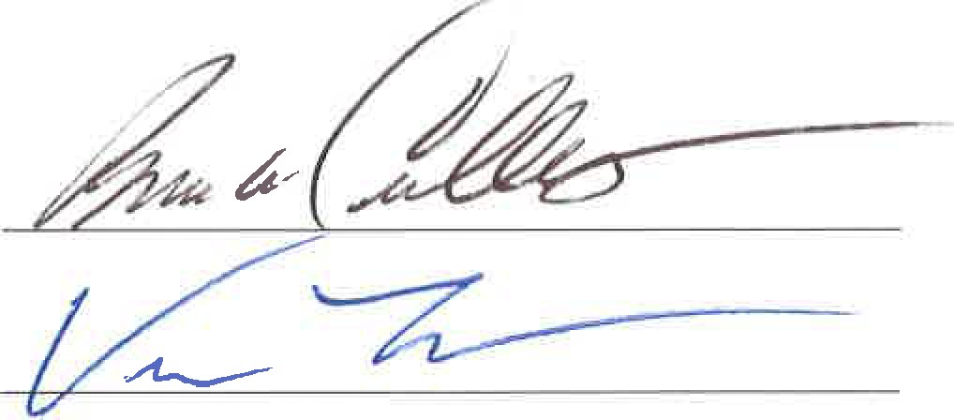
J f
Selectmen Secretary

Bruce Cullett, Chairman

Verne Leach, Selectman

Ed Munch, Selectman Approved: 6/25/18

